- enterR40 configuration :
- Select -system-backup/flash firmware
- 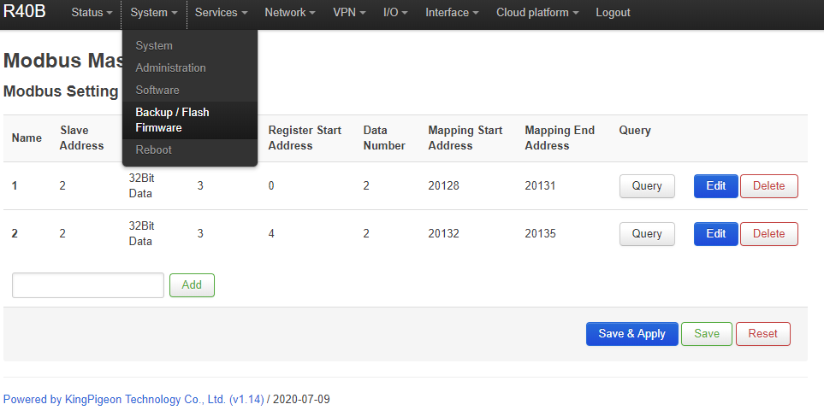
2 Flash operations : select flash image (in the bottom）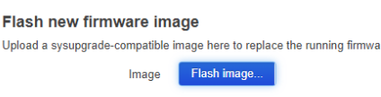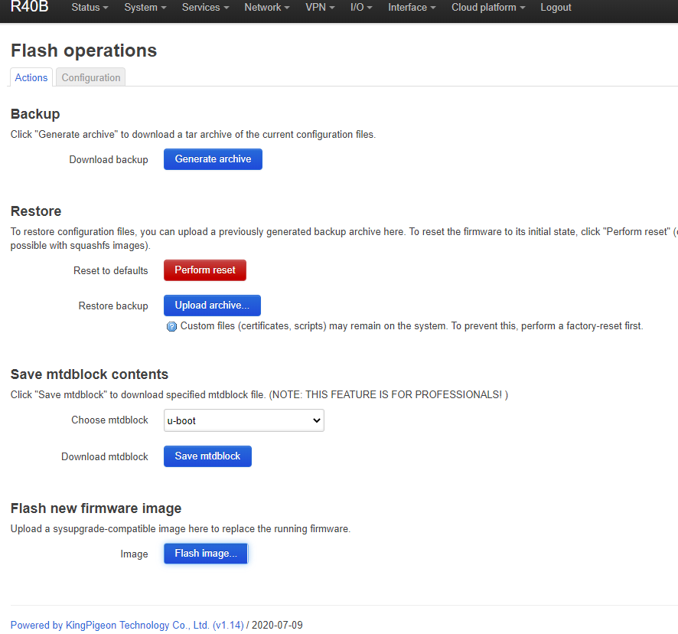

3、select browse
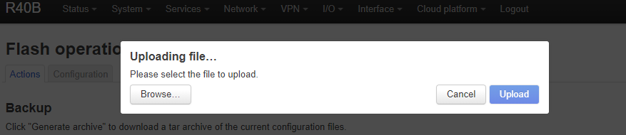

- Select bin file
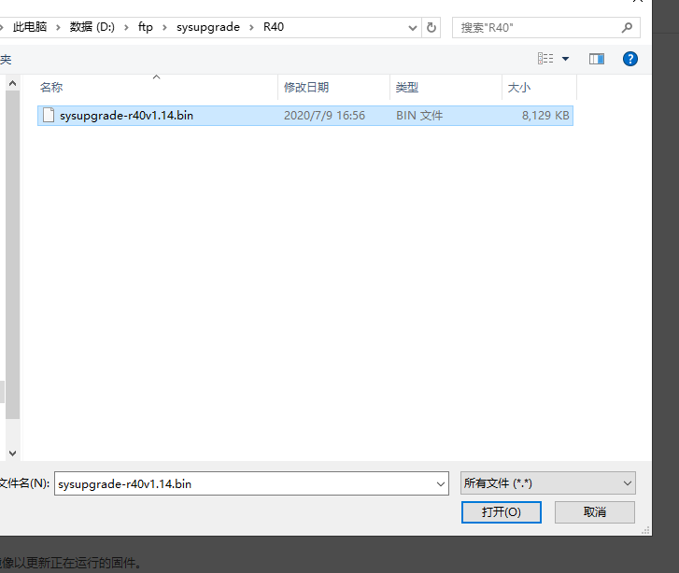

Select upload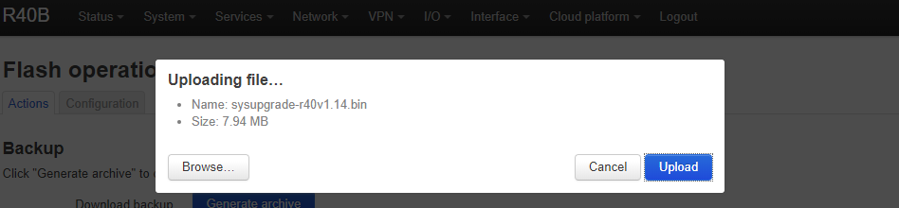

6、After the file upload is complete, you can choose whether you need to save the current configuration, generally select keep current configuration
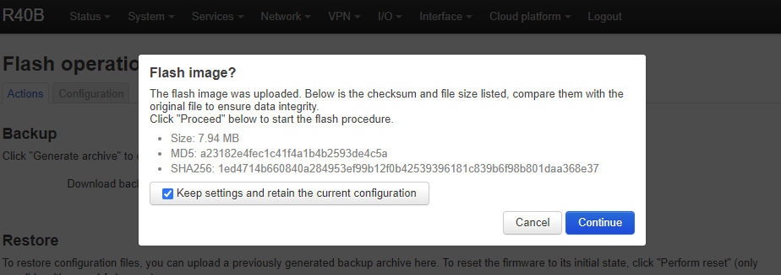

7、click continue
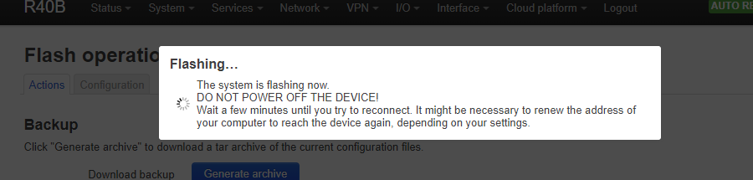
8、done and enter configuration to check if successful.

